Unit testing:

-A software development process

- Individual units are tested

- Code quality

- Save time & money

- Better code more efficiently

Example: Junit for java, jasmine for angular

Karma is the default test runner for Angular CLI: control the creation of HTML file, the opening of browsers, the execution of tests result in the command line

spyOn to call function of dependency class; callThrough decide to whether to call the function or not

Create spy subject to create mock service: createSpyObj

beforeEach in unit test to avoid duplicating the code

Testbed is to avoid creating instance of services and use dependency injection:

TestBed.configureTestingModule({

Providers: [CalcService, {provide: SharedService, useValue: shared }]

});

Shared = TestBed.inject(SharedService);

Calc = Testbed.inject(CalcService);

Provide: SharedService is to create spySubject

Change Describe to xdescribe for pending

Get HttpClientTestingModule pass the data using flush()

Verify() to ensure no ther httpRequest is called

Synchronous and asynchronous block with compileComponents() function (It is returns back into Promise<any>) in unit test

Because when testing service we just need testing module, while in component need to configure testing module and call compile components if not Promise the test may run before the component is init.

Another way: beforeEach(waitForAsync())

QueryAll(By.Css); Use Promise and flush() for asynchronous function

Promise is always executed before setTimeout because setTimeOut is macroTask while promise is microTask

flushMicrotasks() clear only micro task queue

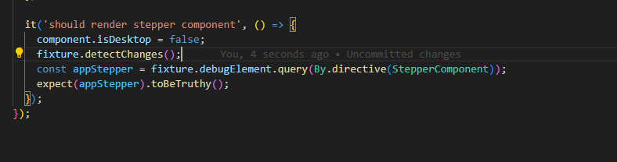

Ticket issue: 4 , 5, 6, 7, 8, 12

10, danh dau s



Front end hiện thị ra sao? Hay back end nó làm?

5, Barcode invalid

12, mobile ok desktop chua ro; cho no’ true la` dc

13, failure barcode and barcode mismatch

Desktop: The barcode does not match the expected kit nhung ma` con` button Cancel

14 khong hieu?

15

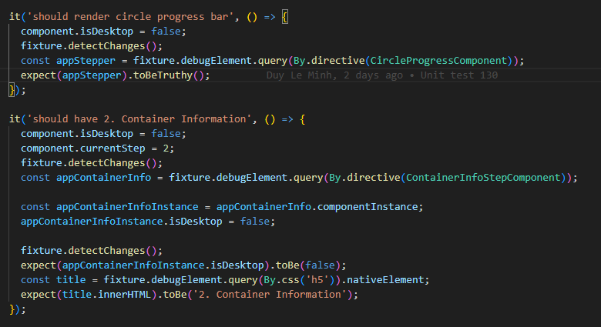2

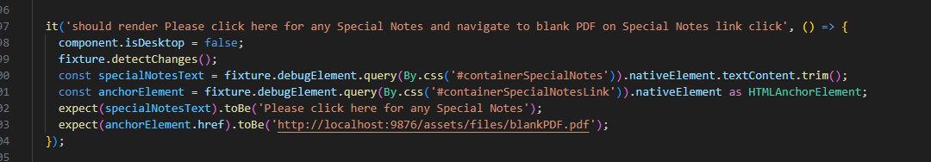

3

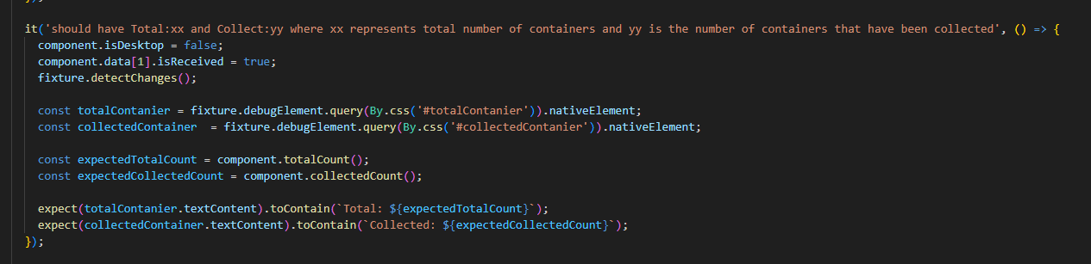4

5

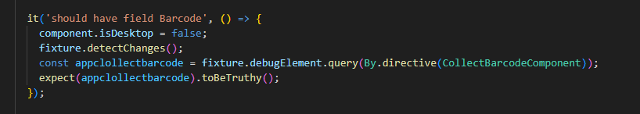

6, 10, 12

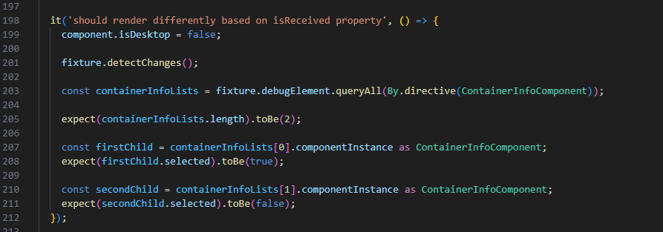

7, 8

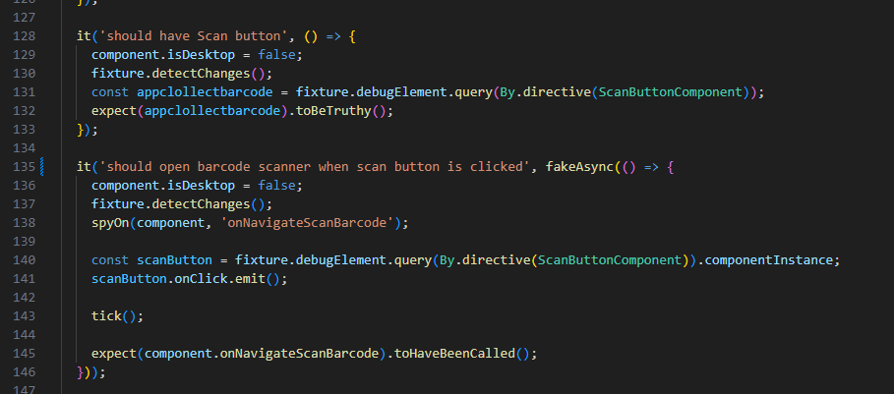

20

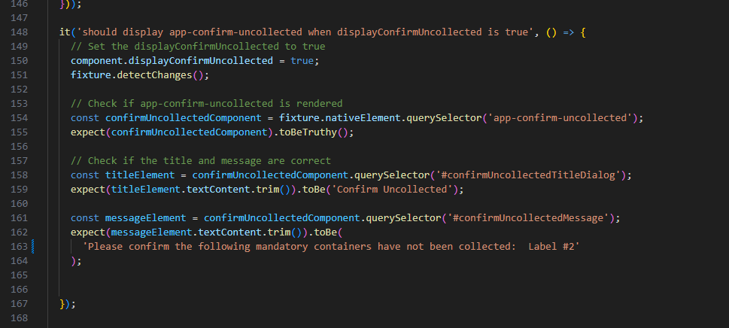

21, 22  
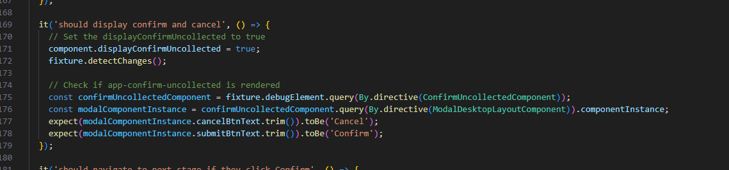

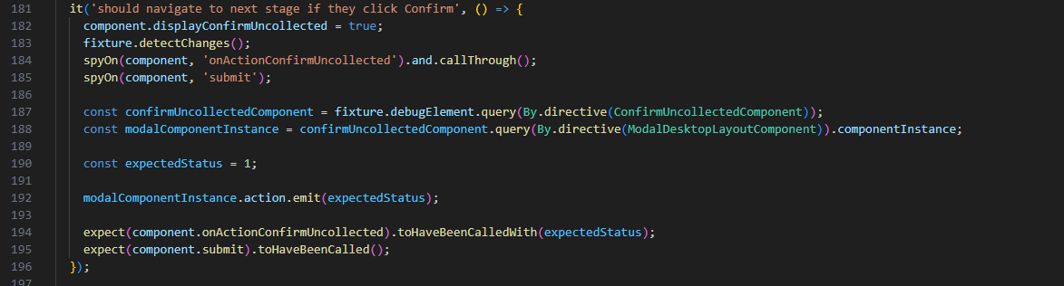

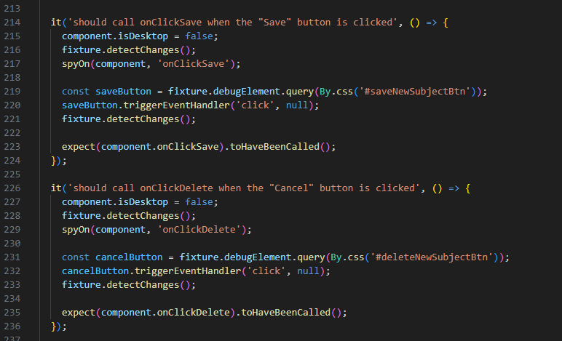23, 24

28

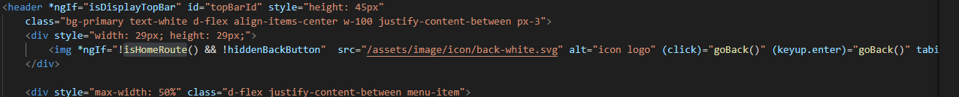

25, 26

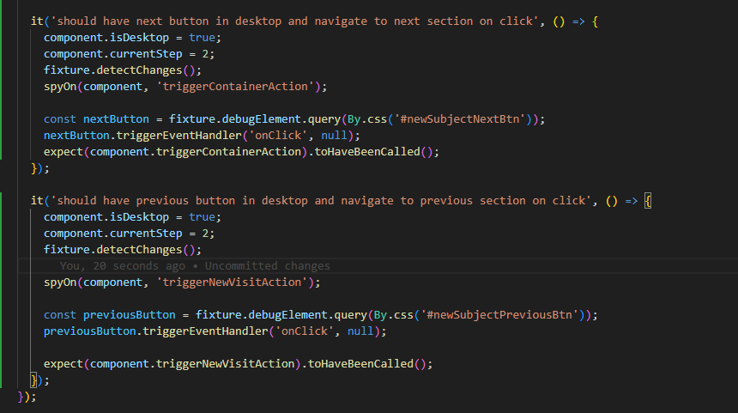

Data nam` trong accession.reducer

barcode mismatch  
13, 16, 18

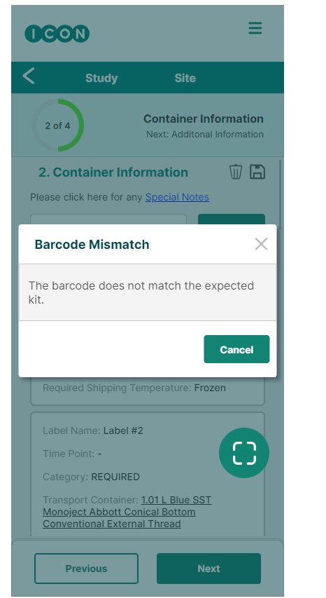

18, 21 chung 1 van’ de`